NUMERACY LESSON GUIDE FOR BERRIES 4 -5 YRS CLASS

Middle 4 – 5 YEARS TERM ONE 2023

WEEK ONE

LESSON 1 & 2

Orientation

**Lesson 3**

**Recognition of shapes. (Draw the same)**

**Lesson 4**

**Lesson 5**

**Match the same shape**

**WEEK TWO**

Lesson 1

**Match the same shape**

**Lesson 2**

**Listen and draw**

**Lesson 3**

**Tick the odd man out.**

**Lesson4**

**Circle the odd man out**

**Lesson 5**

**Match to the belonging**





**WEEK THREE**

Lesson 1

Counting numbers 1 – 10

**Copy and write**

0 l 2 3 4 5

6 7 8 9 l0

**Lesson 2**

**Match the same numbers**

5 4

3 9

7 2

4 6

9 5

2 3

6 7

**Lesson 3**

**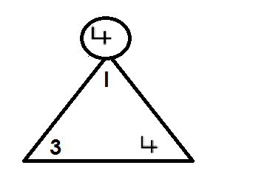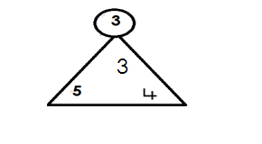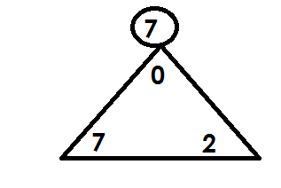Circle the given number**

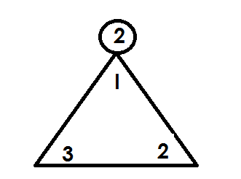

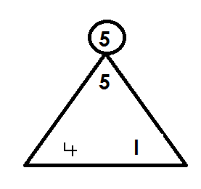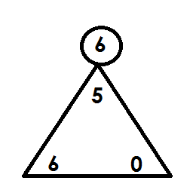

**Lesson4**

**Circle the odd man out.**

2 2 3 2

4 4 4 0

I 6 6 6

5 3 3 3

7 7 9 7

5 I 5 5

**Lesson 5**

**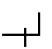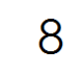Put me right**

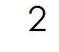



**WEEK FOUR**

**Lesson 1**

**Fill in the missing numbers**

**0 \_\_\_\_ 2 \_\_\_\_ 4 \_\_\_\_ 6 \_\_\_\_ 8 \_\_\_\_ l0**

**l \_\_\_\_ 3 \_\_\_\_ 5 \_\_\_\_ 7 \_\_\_\_ 9 \_\_\_\_**

**Lesson 2**

**Count and match**

****





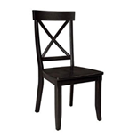

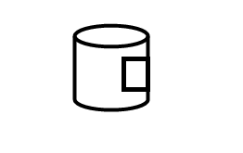

**Lesson 3**

**Count and match**

6

8



7



9



10

**Lesson 4**

**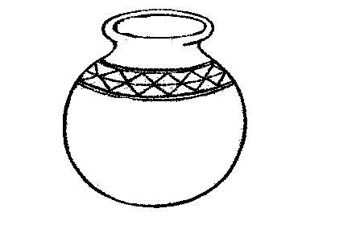Count and circle**

** 3 2 0**



**4 5 2**



**7 4 l**

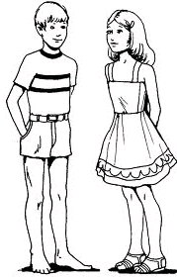

**5 6 8**



 **0 l 2**

**Lesson 5**

**Count and ring**

 l 7 3

**Count and ring**



 9 5 2

4 4 5 l0

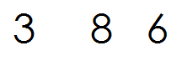

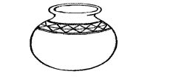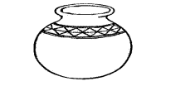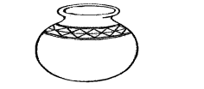

 6 7 4

**WEEK FIVE**

**Lesson 1**

**Count and write**







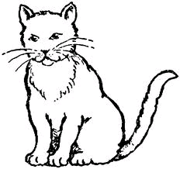









**Lesson 2**

**Count and write**

****









**Count and write**









**Lesson 3**

**Count and write**





**Lesson 4**

**Draw for the given number**

**4 6**

 **3 5**

I 2

**Lesson 5**

**Draw for the number**

l0 =

2 =

7 =

4 =

9 =

3 =

**WEEK SIX**

**Lesson I and 2**

Write the next number

0

0 I 2

0 I 2 3

0 I 2 3 4 5

0 I 2 3 4 5 6

0 I 2 3 4 5 6 7

0 I 2 3 4 5 6 7 8

0 I 2 3 4 5 6 7 8 9

**Lesson 3**

**Joining dots**

0 3 4 7 8

I 2 5 6 9 l0

**Lesson 4**

**Joining dots**

0 3 4 7 8 9

l 2 5 6 l0

**Lesson 5**

**Shade for the given numbers**

3 =

6 =

I =

4 =

2 =

O =

**WEEK SEVEN**

**Lesson 1**

**Number names**

**Copy and learn**

0 = Zero 3 = three 6 = six 9 = nine

I = one 4 = four 7 = seven I0 = ten

2 = two 5 = five 8 = eight

**Lessons 2**

**Read and match**

I five

3 two

0 four

5 one

2 three

4 zero

**Lesson 3**

**Read and match**

7 eight

10 six

8 nine

6 seven

NA02413_9 ten

**Lesson 4**

**Write in figures**

zero three six

four nine ten

seven five one

two eight

**Write in words**

2 9 6 3

4 7 8 I

0 5

**WEEK EIGHT**

**LESSON 1**

**Read and draw**

two books three boys

five pots four cups

one tree six eggs

**Lesson 2**

**Add the pictures**

****









**Lesson 3**

**Add the pictures.**







NA02413_

**Lesson 4**

**Add the numbers**

2 + l =

3 + 2 =

I + I =

**Lesson 5**

Add these numbers

3 + 4 =

2 + 2 =

5 + I =

2 + 0 =

3 + 3 =

**WEEK NINE**

**Lesson 1**

**Recognition of numbers 11 – 15**

**Copy and write**

II I2 I3 I4 I5

**Lesson 2**

Match the same

I I I3

I2 I4

I3 I5

I4 I I

I5 I2

**Lesson 3**

**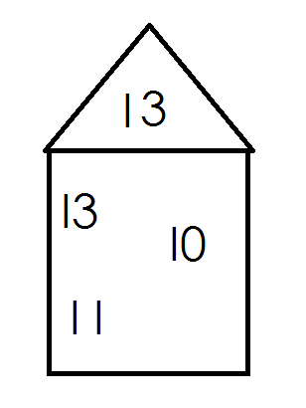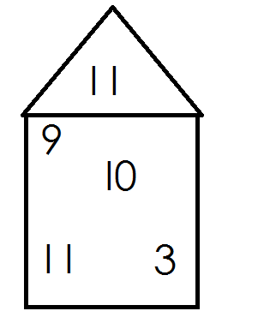Circle the given number**

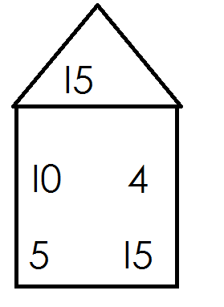

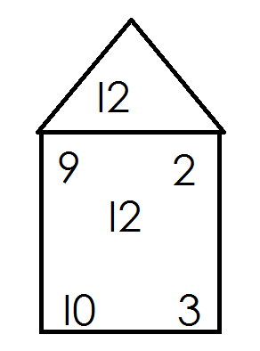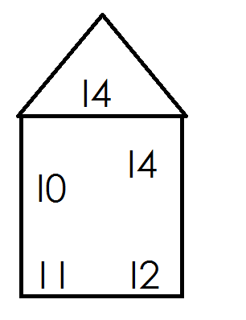

**Lesson 4**

**Circle the odd man out**

I3 I0 I3 I3

I5 I5 5 I5

I I I I I I I 2

I 4 6 I 4 I 4

I 2 9 I 2 4

**Lesson 5**

Fill in the missing numbers

I0 \_\_\_\_ I 2 \_\_\_\_\_ I 4 \_\_\_\_\_

I I \_\_\_\_ \_\_\_\_ \_\_\_\_ \_\_\_\_

I I I2 \_\_\_\_\_ \_\_\_\_ \_\_\_\_